

United Nations Human Rights Council
60th session (8 September – 8 October 2025)

Items 2 & 10 – Enhanced Interactive Dialogue on the Democratic Republic of the Congo (res. S-37/1 & res. 57/34)

Oral Statement, International Federation of ACATs on behalf of the United Against Torture Consortium

9th September 2025

The United Against Torture Consortium, bringing together FIACAT, APT, IRCT, OMCT, Omega Research Foundation and REDRESS – together with AFIA MAMA and our partners from Congolese civil society, welcomes the Fact-Finding Mission’s final report.

The mandate of the Fact-Finding Mission to gather, preserve and assess evidence, had led the mission to find reasonable grounds to believe that all parties to the conflict have committed war crimes and crimes against humanity,and to identify alleged perpetrators, This work represents a crucial step in the fight against impunity, particularly in a context where ongoing peace processes fail to address the right to justice for victims.

Amidst the collapse of state judicial and penitentiary institutions, and what the report describes as “pervasive self-censorship" driven by fear of reprisals and the numerous violations committed against civil society actors and their relatives in North and South Kivu, our organizations express serious concern over the postponement of the Commission of Inquiry responsible for continuing the work of the Fact-Finding Mission. This delay constitutes a major setback for the documentation of violations committed in Eastern DRC and risks undermining any future accountability and reparations initiatives.

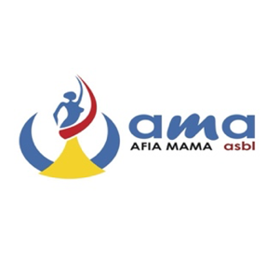
Our organizations seek clarification on the measures the Office of the High Commissioner will adopt to maintain continuous documentation of violations in the eastern provinces of the DRC pending the establishment of the Commission of Inquiry. We also wish to know whether the Office plans to enhance technical and logistical support to Congolese civil society organizations to ensure their effective participation in independent and sustainable monitoring, in line with the recommendations of the Fact-Finding Mission?

Thank you.


